Day in the Life of the Hudson River 10/14/22
Pier 1 Lighthouse Museum, Staten Island
RIVER MILE: -4.5
Salt Front: ~ 76
Dave Scheffler & Curtis High School
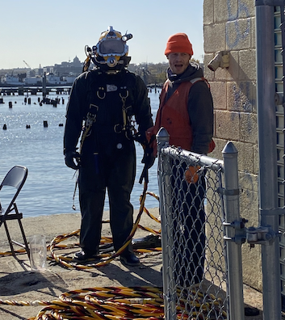
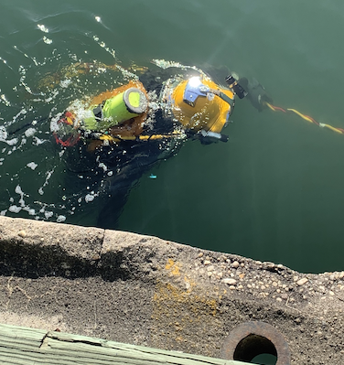
30 students & 3 adults
Latitude 40.640951 N & Longitude – 74.073463 W
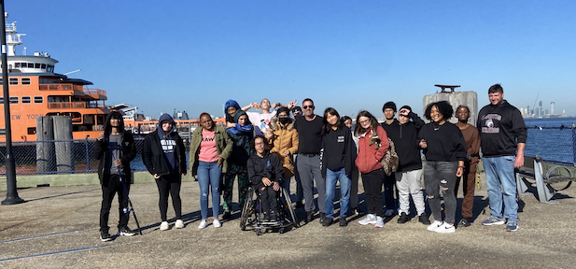
Location: Pier 1 Lighthouse Museum, Staten Island, NY
Area: Pier with parking lot.
Surrounding Land Use: 100% Urban
Sampling Site: Wood bulkhead, concreate bulkhead, banks altered, riprap
Shoreline: 20% sandy, 30% muddy, 50% rocky.
River Bottom: Rocky
Water : Calm
*NR = Not read/recorded
ITEM |  | Time |  | Reading |  |  |  | Comments
Physical
Air Temperature |  | 9:35 AM  10:23 AM  11:35 AM |  | º C |  |  | 48 º F  51º F  56 º F
Wind Speed: |  | 10:30 AM |  | Anemometer |  |  | Beaufort  1 | Direction  SE
Weather today |  | 11:30 AM |  | <51-75% cloud cover |  |  | No rain
Weather the past 3 days: |  | Was warmer than today!
Tides- |  | Time |  | Rising, Falling, Unchanged |  |  | Height (cm)
 |  | 9:30 AM-  10:30 AM 11:30 AM |  | Set  Rising  Falling |  |  | 299.72 cm  335 cm  320 cm
Current- |  | Time |  | Cm/sec |  | Knots | North/South | Ebb/Flood/Slack
 |  | 9:40 AM  10:40 AM  11:40 AM |  | 6.4  3.41  10 |  | 1.25  NR  1.94 |  | Flood/Slack  Slack  Ebb/Slack
Water Temperature- |  | 11:30 AM |  | 17.2 º C |  |  | 72 º F
Turbidity- Long Sight Tube |  | 11:30 AM |  | 104.3 cm
Chemical
Salinity- Hydrometer |  | 10:30 AM |  | 27 ppt
Standardized Salinity- NR
DO – NR |  | Time |  | Temp |  |  | ppm DO | % Saturation
 |  | NR |  | 22 º C |  |  | NR | NR
pH – Color Match Kit
Nitrates- NR
Phosphates- NR
Biological
Fish – Rod & Reel |  | Number |  | Name |  |  | Length of longest | Length of smallest
 |  | 5  4 |  | Tautog  Porgy |  |  | 45.72 cm  24.13 cm | 15.24 cm  20.32 cm
Fish Totals |  | TOTAL: 9 |  | Diversity: 2 |  |  |  | *Note 2 dogfish left by anglers (60.96 & 45.72 cm
Macroinvertebrates |  | Number |  | Name |  |  | Length of longest | Length of smallest
*no small crabs of fish this year. Oyster cages had been vandalized & removed
Macroinvertebrate Totals |  | TOTAL:0 |  | Diversity: 0
Sediment Core
Length | H2S smell |  | Oxid Top |  | Oil |  | Grain Size | Other Features
NR | No |  | Yes |  | NR |  | Abundant: clay  Common: mud, sand | Common: macroinvertebrates, shells, living vegetation
Boats-NR
 | Time |  | Name |  | Color |  | North/Southbound | Light/Loaded
Commercial | 10:00AM |  | McAllister Tug |  | Red |  | NE | Working
 | 10:00 AM |  | Maersk |  | Light Black, Red, |  | NE | Loaded
 | intermittent |  | SI Ferry |  | Orange |  | NE | passengers
Recreational |  |  | Sailboat |  | White |  | S | NA
 |  |  | Fishing Boat |  | White, Blue |  | S/drifting | Light
 |  |  | Fishing Boat |  | White |  | North
Observations | Kids were amazed after pulling water sample up from the bay and discovering how clear the water actually was.  From the pier the kids observed brownish dark color to the water, mostly due to the muddy brown bottom at our test site. This was also enhanced by the overcast day. It appeared that we could see deeper into the long site tube than from the pier itself. The dock is also 7 feet above the water at high tide.

